Created a collection library_db
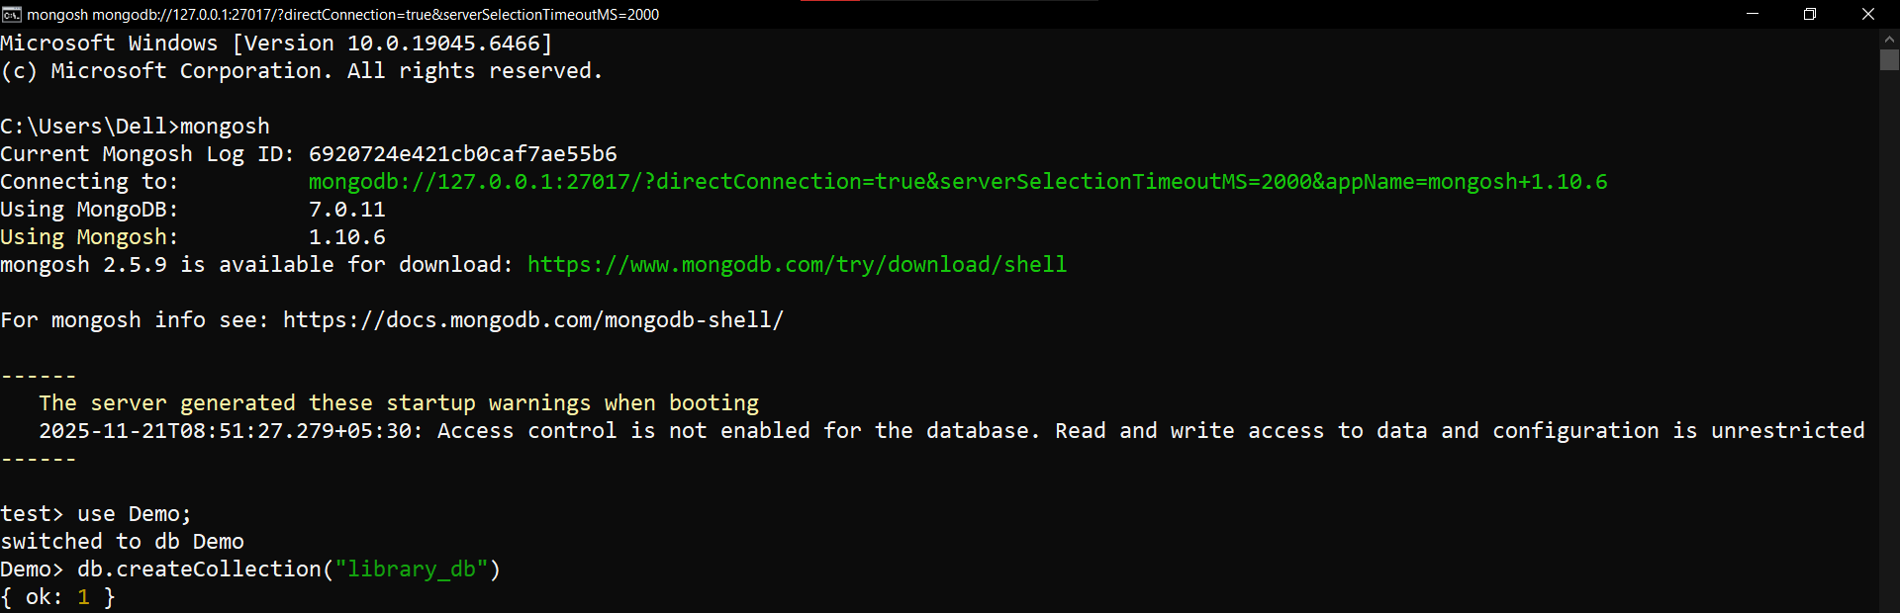

Inserted given data.
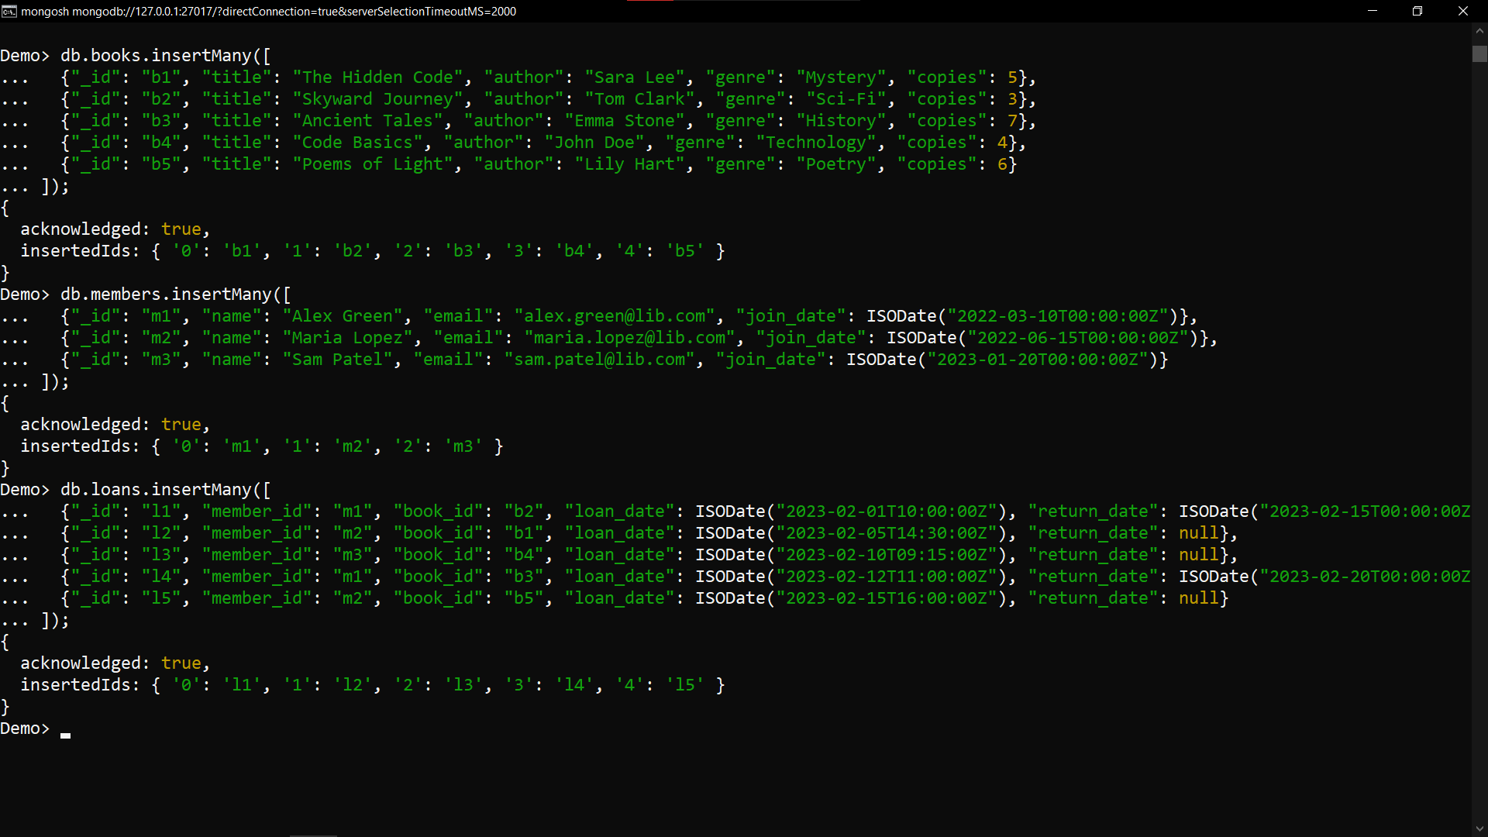

1: Insert a New Book

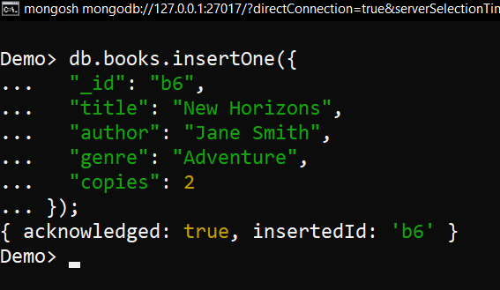

2: Find Members by Join Date
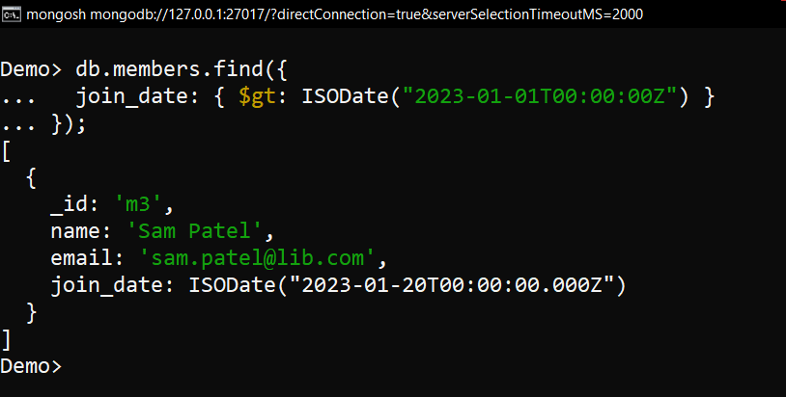

3: Update Member Email
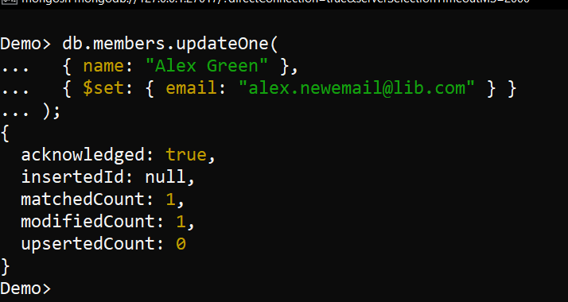

4: Delete a Loan
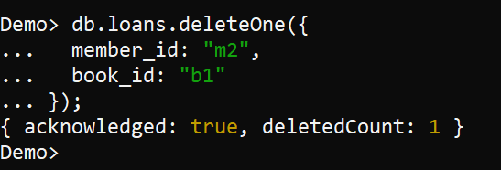

5: Create Index on Book Title
6: Create Index on Member Name
7: Compound Index on Loans
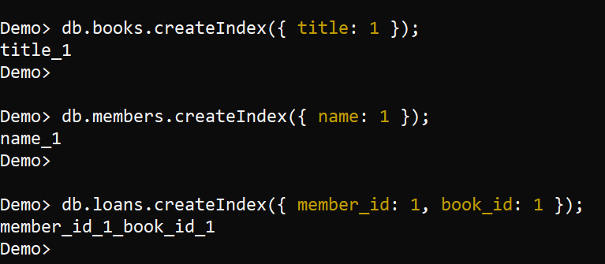
Bonus :
Explanation :
- Index on title improves search performance when querying books by title, useful for large collections.
- Index on name speeds up lookups or sorting by member names.
- Compound index on member_id and book_id optimizes queries that filter by both fields, common in loan lookups.
8: Top 3 Most Borrowed Books
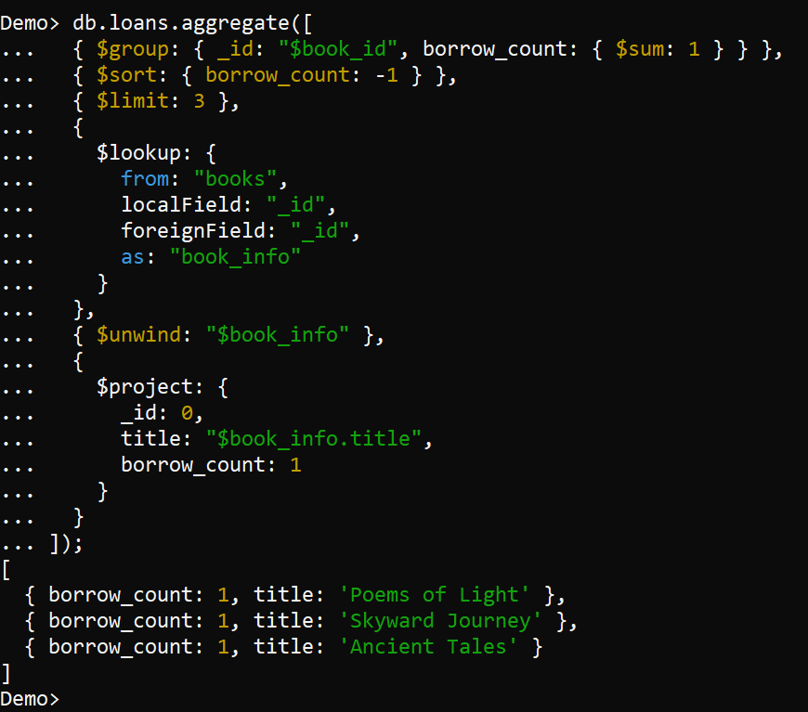

9: Average Loans per Member
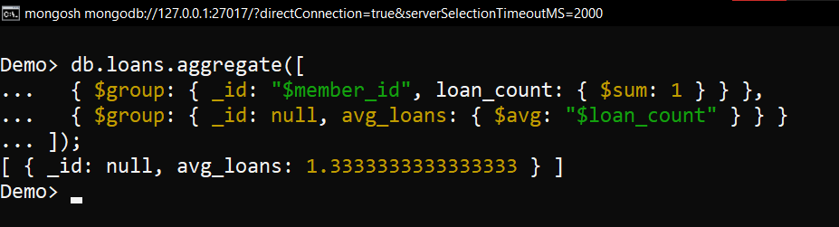

10: Genre With the Most Loans
